Covalent Bonding
This is the electrostatic attraction between positive nuclei and negative electron pairs shared between nuclei of two or more non-metals.

Covalent bonds are a balance between the positive nuclei and the negative electrons, and the repulsion of the two positive nuclei.

Properties:
- Attraction only local between a pair of electrons.
- Only a few atoms are bonded
- Does not conduct electricity – no ions to carry charge

E.g. in CO₂ there are two double covalent bonds:
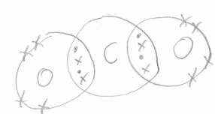
Exceptions:
Boron Tetrafluoride forms 3 covalent bonds, meaning that there will only be 6 electrons in the outer shell of boron.

Phosphorus can form 5 covalent bonds as the 3rd shell can hold 18 electrons, and so there can be 5 bonding pairs because a 3s electron is promoted into the 3d orbital.

Sulphur can vary the amount of bonds with fluorine, so SF₂, SF₄, and SF₆ can all exist.

Dative / co-ordinate bonds
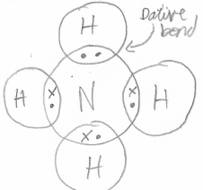
This is where an ion covalently bonds to an atom, so the ion uses both 2 electrons from the atom rather than sharing 1 from each.

